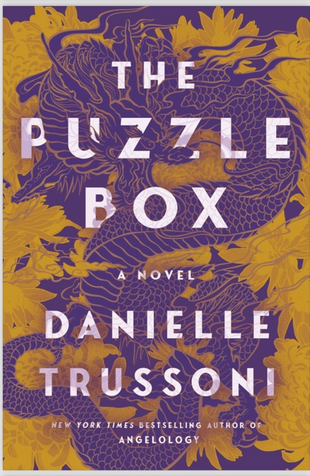

**[A](https://www.latimes.com/entertainment-arts/books/story/2024-09-03/books-to-read-fall-2024-most-anticipated) *[Los Angeles Times](https://www.latimes.com/entertainment-arts/books/story/2024-09-03/books-to-read-fall-2024-most-anticipated)* [Most Anticipated Book of Fall 2024](https://www.latimes.com/entertainment-arts/books/story/2024-09-03/books-to-read-fall-2024-most-anticipated)**

“Polished prose, an action-packed quest across Japan and puzzles within the story too? Sign me up!”

[**One of BookBub's Best Mysteries and Thrillers of Fall 2024**](https://www.bookbub.com/blog/best-mystery-thriller-books-fall-2024)

**A Barnes & Noble Most Anticipated October Book**

“A first-rate thriller. More, please!”***—Booklist***

“Astonishing…This clever and satisfying novel cements Mike Brink as an action hero for the ages.” ***—Publishers Weekly,* starred review**

THE PUZZLE BOX

**by Danielle Trussoni**

**A Random House Hardcover ~ October 8, 2024**

*New York Times* bestselling author **Danielle Trussoni** brings together the best elements of literary and popular fiction in her thrillers—they’re smart and complex, with fascinating characters, intricately plotted storylines, and timely themes that resonate with a wide readership. Her latest book, [**THE PUZZLE BOX**](https://www.penguinrandomhouse.com/books/717439/the-puzzle-box-by-danielle-trussoni/), which Random House will publish in hardcover on October 8, 2024, is no exception. The story centers on a neurodivergent protagonist in a high stakes international adventure, racing against the clock and hidden enemies to solve the world’s most complex puzzle. And at the same time, it’s a multi-layered novel with strong feminist overtones, as it shines a bright light on the true history of female rulers in Japan.

In the novel, puzzle genius Mike Brink has been invited to Tokyo to open the legendary Dragon Box, a mysterious nineteenth-century puzzle that has remained unsolved for over 150 years. Mike’s mission to solve the mystery takes him across Japan, from the Imperial Palace in Tokyo to the pristine forests of Hakone to historic Kyoto to an ancient cave in Kyushu, and he becomes caught in the power struggle of two sisters descended from an ancient samurai clan. The secrets of their family are locked in a deadly puzzle box​ that, when opened, ​could change the future of the Japanese monarchy and women in Japan.

Danielle Trussoni taught English in a remote Japanese village for two years, during which she earned a brown belt in the martial art *wa-do*, wrote her first novel, and gave birth to a son. She fell in love with the country and its customs: “My time living in Japan was transformative. By the time I left, I was a writer and a mother. In **THE PUZZLE BOX**, I incorporated elements of Japanese culture and history that I’d learned about—Shinto religion, the *Onna-Bugeisha* female samurai, and the Imperial family’s drama of succession. This new book is very close to my heart, as it’s a love letter to the country that is so meaningful to me.”

**About the Author**

**Danielle Trussoni** is the *New York Times*bestselling author of *The Ancestor, Angelology*and *Angelopolis*, all *New York Times* Notable Books, and *The Puzzle Master,* chosen by *The Washington Post* as one of their Best Thrillers of 2023. Her memoir, *Falling Through the Earth,* was selected by *The New York Times* as one of the Top Ten Books of the Year.

Danielle is a graduate of the Iowa Writers' Workshop and winner of the Michener-Copernicus Society of America Fellowship, and her work has been translated into more than thirty languages.

Website: [www.danielletrussoni.com](http://www.danielletrussoni.com)

Instagram: [@danielletrussoni](https://www.instagram.com/danielletrussoni/)

Threads: [@danielletrussoni](https://www.threads.net/@danielletrussoni)

TikTok: [@danielletrussoni9](https://www.tiktok.com/@danielletrussoni9)

X: [@DaniTrussoni](https://twitter.com/DaniTrussoni)

**Additional Social media tags**

Facebook: [@PenguinRandomHouse](https://www.facebook.com/PenguinRandomHouse/), [@meganbeatiecommunications](https://www.facebook.com/search/top?q=megan%20beatie%20communications)

Instagram: [@penguinrandomhouse](https://www.instagram.com/penguinrandomhouse/), [@mbc_books](https://www.instagram.com/mbc_books/)

Tiktok: [@penguinrandomhouse](https://www.tiktok.com/@penguinrandomhouse), [@mbc_books](https://www.tiktok.com/@mbc_books)

**Suggested Interview Questions**

* You lived in Japan for two years and said that you were inspired to write this novel because of the experience. What aspects of living in Japan inspired you? How did they inform the writing of this book? What kind of research did you do when you embarked upon this project?
* The hero of this novel—an ingenious puzzle solver named Mike Brink—suffers from a rare, but real condition known as Acquired Savant Syndrome. It's a fascinating and rare disorder. Can you tell us about it and how you used your research into this condition for your hero?
* You've based this novel on a 19th century puzzle box created by the Imperial family of Japan. How much of that story is real? How much did you fictionalize? Where do you draw the line between borrowing from real life and invention?
* In previous interviews, you've mentioned that the hero of this book was loosely inspired by your son, who had a photographic memory as a child. Do you often find yourself inspired to write fiction about the people in your life? Does it change the way you create characters? Has your son read the book and what was his reaction?
* Not to give too much away (no spoilers!), but the solution to the mystery touches on a real-life debate currently happening in Japan about the succession of the Imperial Family.  Can you talk a little about why this topic is of interest to you, and why it was important to incorporate feminist themes and the history of female rulers and succession laws in Japan into your novel?

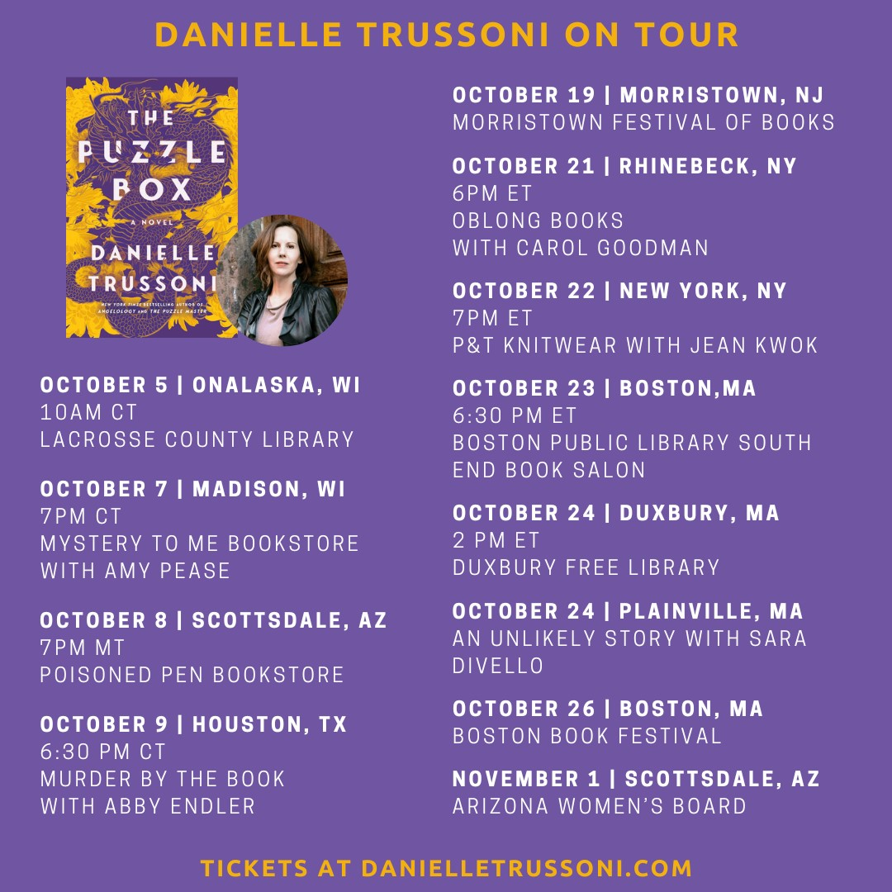

**Additional Advance praise for THE PUZZLE BOX**

“You’ll hit the ground running in this rip-roaring adventure thriller that sends you across the breadth of Japan in search of ancient answers. Trussoni’s novel is an escapist, puzzle box of delights: a neurodivergent hero, an unsolvable mystery and death hanging over every move—you’ll whip through the pages. A book, itself, as intricate and surprising as a Puzzle Box.”

—**Catherine Steadman, *New York Times* bestselling author of *Something in the Water***

“Who should read Danielle Trussoni's latest? Readers of breathless adventure in the Dan Brown vein; readers of literate, sophisticated book-club fiction; readers of boldly plotted brain-teasers (think classic Agatha Christie, but more provocative); readers who love storytelling so fresh and original that it resists labels. So who should read *The Puzzle Box*? In a word: everyone.” **—AJ Finn, *New York Times* bestselling author of *The Woman in the Window***

*“The Puzzle Box* is a rare treasure: a gorgeous and immersive exploration of power, sisterhood, and culture wrapped in an addictive page-turning adventure filled with royal secrets and mystery. Set in Japan, this novel took me on an adventure like I’d never experienced before. I was up all night turning the pages following these unforgettable characters…A must-read!”**—Jean Kwok, *New York Times* bestselling author of *Searching for Sylvie Lee* and *The Leftover Woman***

**Praise and Accolades for *The Puzzle Master***

**A *Washington Post ·* PopSugar · BookReporter·CrimeReads·Barnes & Noble**

**—BEST BOOK OF THE YEAR—**

**—A CBS New York Book Club Pick—**

“In short: *The Puzzle Master* = (*The Da Vinci Code* + *The Silent Patient* + sprinkle of Stephen King) x gorgeous writing.” —**Angie Kim**

“All bets are off, and your summer beach read is a lock.” **—*NPR***

“A surefire hit… [*The Puzzle Master*] is an ambitious story, expertly told…. A sequel, *The Puzzle Box*, is in the works, and it can’t come soon enough.” **—*Booklist***

“This immersive, brilliant book is a labyrinth of ciphers, cryptograms, logic puzzles, word puzzles, and a doozy of a conspiracy.” **—*Minneapolis Star Tribune***

“The many irresistible elements in Danielle Trussoni’s *The Puzzle Master* include Mike Brink, a preternaturally brilliant man billed as ‘the most talented puzzleist in the world.”

**—*The New York Times Book Review***

“Danielle Trussoni melds a heady brew of genres—mystery, horror, supernatural, magical realism, ancient history, mysticism and plain old puzzles…The packed plot could easily spin out of control with so many elements but Trussoni keeps a firm hand on her sixth novel…Mike Brink’s skills pale next to Trussoni’s ability to create involving mazes.” **—*South Florida Sun Sentinel***

“[A] marvel…It has been some time since I read a novel I found as compelling as this one in two particular ways. One, the book is a page-turner, pure and simple; and two, it’s a thing to be admired in how it is structured. That Trussoni has erudition is obvious. What’s great for the reader is that she doesn’t get carried away showing it off. The learning all serves the end of suspenseful and propulsive storytelling.” **—*Mystery Tribune***

“Intriguing…Several subplots involve horror, mysticism, religious fantasy and, perhaps most importantly, dolls. Keeping all of these elements moving toward an exciting conclusion is the mark of an excellent mystery novel. *The Puzzle Master* accomplishes that task in impressive fashion.”

**—Bookreporter.com**

“[Trussoni] is at the top of her game in involving the reader in the puzzle-solving process, making the most of historic settings, including the Pierpont Morgan Library, and making the book’s *Da Vinci Code*– like trappings pay off. The Kabbalah meets the *New York Times* crossword in a brainy thriller.”

**—*Kirkus Reviews***

“I loved Danielle Trussoni’s *The Puzzle Master*, an erudite, super compelling mystery that I couldn’t put down!” —**Lisa Scottoline, *New York Times* bestselling author**

“Danielle Trussoni’s *The Puzzle Master* is utterly absorbing. More than just a first-rate, lock-and-key thriller (which it definitely is), Trussoni’s novel dives deep into fundamental questions about life and death, the nature of consciousness, and the unknowable reality of the divine.”

**—Justin Cronin, #1 *New York Times* bestselling author of *The Passage Trilogy***

“In the nimble, talented hands of Trussoni the pages fly with meticulously crafted set pieces routinely punctured by machine gun bursts of visceral action. Here’s to the next puzzle Brink finds himself party to.” **—David Baldacci, #1 *New York Times* bestselling author**